NOAA Weather Data — JFK Airport
Data Acquisition, Cleaning, and Exploratory Analysis
Week 1 Deliverable — Data Acquisition, Cleaning, and Exploratory Analysis
Dataset: NOAA Local Climatological Data — JFK Airport, Jan 2010–Jul 2018
Tools: Python, pandas, NumPy, Matplotlib, Seaborn

1. Introduction
This report documents the acquisition, cleaning, and exploratory analysis of hourly weather observations recorded at JFK Airport. The dataset was selected because it is a real-world, publicly available time series with realistic data-quality issues — missing readings, inconsistent formatting, and sensor-error values — making it well suited to demonstrating a complete cleaning workflow rather than a synthetic, already-tidy dataset.
The objective of this stage of the project is to take the raw hourly feed and produce an analysis-ready dataset, then use exploratory data analysis (EDA) to surface the patterns, data-quality issues, and relationships present in the data before any modeling is attempted.

2. Data Acquisition
Source: NOAA Local Climatological Data (LCD) for JFK Airport, a public dataset covering hourly observations of temperature, humidity, wind, pressure, visibility, and precipitation.
Access point used: A maintained public mirror of this dataset on Kaggle (“NOAA Weather Data - JFK Airport”), used because the dataset's original hosting page (IBM's Data Asset eXchange) has since been deprecated and no longer serves the file.
Size and span: 114,546 raw hourly observations across 12 core climatological variables, spanning January 2010 to July 2018.
Why this dataset: Aviation weather data is dense, continuous, and governed by clear documented value ranges (e.g. visibility, pressure tendency codes), which makes it possible to validate cleaning decisions against an authoritative reference (NOAA's Local Climatological Data documentation) rather than guessing at reasonable bounds.
Loading the raw file:
import pandas as pd, numpy as np, re
raw = pd.read_csv('jfk-weather.csv', parse_dates=['DATE'])
raw.head()
raw.dtypes

3. Data Cleaning
Cleaning was carried out as a sequence of explicit, individually justified steps rather than a single blanket operation, so that each transformation of the data is traceable and defensible.

3.1 Column Selection
The raw export mixes hourly, daily, and monthly summary fields in a single table. Only the hourly fields relevant to this analysis were retained, and the timestamp was set as the index.
cols = ['DATE','HOURLYVISIBILITY','HOURLYDRYBULBTEMPF','HOURLYWETBULBTEMPF',
'HOURLYDewPointTempF','HOURLYRelativeHumidity','HOURLYWindSpeed',
'HOURLYWindDirection','HOURLYStationPressure','HOURLYPressureTendency',
'HOURLYSeaLevelPressure','HOURLYPrecip','HOURLYAltimeterSetting']
df = raw[cols].set_index(pd.DatetimeIndex(raw['DATE'])).drop(columns='DATE')
Rationale: mixing hourly and monthly-granularity fields in the same table would make later aggregate statistics meaningless, since they would be averaging figures collected at different time resolutions.

3.2 Standardizing the Missing-Value Marker
NOAA encodes unrecorded readings with an asterisk character, which pandas does not recognize as missing by default.
df = df.replace('*', np.nan)

3.3 Handling Precipitation's Special Cases
Inspection of the precipitation field's unique values revealed two non-numeric cases: the letter 'T', denoting a trace amount too small for the gauge to measure precisely, and a single corrupted reading.
df['HOURLYPrecip'].unique()
df['HOURLYPrecip'] = df['HOURLYPrecip'].replace('T', '0.00')
df['HOURLYPrecip'] = df['HOURLYPrecip'].replace('0.020.01s', np.nan)
Rationale: 'T' is a real, meteorologically meaningful reading rather than a data-quality problem, so it was explicitly coded as 0.00 instead of being dropped or left as text. The single corrupted value was treated as a sensor/transcription error and nulled.

3.4 Converting Fields to Numeric Types
messy_cols = cols[1:]
for c in messy_cols:
df[c] = (df[c]
.apply(lambda x: re.sub('[^0-9,.-]', '', x) if isinstance(x, str) else x)
.replace('', np.nan)
.astype('float32'))
float32 was used instead of the pandas default float64: with 100,000+ rows this halves memory usage with no meaningful loss of precision for weather-sensor readings.

3.5 Validating Values Against Documented Ranges
NOAA's Local Climatological Data documentation specifies that HOURLYVISIBILITY must fall between 0 and 10 miles and HOURLYPressureTendency between 0 and 8. Values outside these bounds indicate a sensor fault, not a real observation, and were treated as missing rather than as valid extreme readings.
df.loc[(df['HOURLYVISIBILITY'] < 0) | (df['HOURLYVISIBILITY'] > 10),
'HOURLYVISIBILITY'] = np.nan
This is domain-aware cleaning: the check uses the field's documented real-world definition to catch a value that still looks numeric and plausible but is not physically valid, which a generic null check would miss entirely.

3.6 Duplicate and Chronological Checks
print(df.index.duplicated().sum(), 'duplicate timestamps')
print(df.index.is_monotonic_increasing, '- sorted ascending')
No duplicate timestamps were found and the index was confirmed to be in strictly increasing chronological order, which is a precondition for the interpolation step that follows.

3.7 Imputing Remaining Missing Values
df['HOURLYPressureTendency'] = df['HOURLYPressureTendency'].ffill()
df = df.interpolate(method='linear')
df = df.iloc[1:] # drop first row: no prior value to interpolate from
Continuous numeric fields were filled by linear interpolation, since weather conditions change gradually hour to hour, making a straight line between the surrounding readings a reasonable estimate. The categorical pressure-tendency field was instead forward-filled, since carrying forward the last known state is more appropriate for a categorical code than interpolating between category numbers. Dropping the affected rows outright was rejected as an option because it would break the continuity of the hourly time series and could bias any later time-based analysis.

3.8 Feature Encoding
Wind direction is a compass angle (0°–360°), where values near 359° and 1° represent almost the same physical direction. Left as a raw number, this discontinuity would distort any correlation or downstream model. It was encoded cyclically using sine and cosine components:
df['wind_direction_sin'] = np.sin(df['HOURLYWindDirection'] * 2 * np.pi / 360)
df['wind_direction_cos'] = np.cos(df['HOURLYWindDirection'] * 2 * np.pi / 360)
df = df.drop(columns='HOURLYWindDirection')
Pressure tendency is documented by NOAA as a three-state category (rising, falling, steady) rather than a continuous quantity, so it was one-hot encoded into three explicit indicator columns:
df['pressure_tendency_incr'] = df['HOURLYPressureTendency'].isin([0,1,2,3]).astype('float32')
df['pressure_tendency_decr'] = df['HOURLYPressureTendency'].isin([5,6,7,8]).astype('float32')
df['pressure_tendency_const'] = (df['HOURLYPressureTendency'] == 4).astype('float32')
df = df.drop(columns='HOURLYPressureTendency')

3.9 Renaming Columns and Exporting
df = df.rename(columns={
'HOURLYVISIBILITY':'visibility','HOURLYDRYBULBTEMPF':'dry_bulb_temp_f',
'HOURLYWETBULBTEMPF':'wet_bulb_temp_f','HOURLYDewPointTempF':'dew_point_temp_f',
'HOURLYRelativeHumidity':'relative_humidity','HOURLYWindSpeed':'wind_speed',
'HOURLYStationPressure':'station_pressure','HOURLYSeaLevelPressure':'sea_level_pressure',
'HOURLYPrecip':'precip','HOURLYAltimeterSetting':'altimeter_setting'})
df.to_csv('jfk_weather_cleaned.csv')
The cleaned dataset was verified to contain 114,544 rows and 15 columns, with zero missing values in every column — confirming that every gap identified during cleaning was successfully resolved.

4. Exploratory Data Analysis
With a validated, complete dataset in hand, exploratory analysis was used to surface data-quality confirmation, distributional shape, seasonal trends, and relationships between variables.
data = pd.read_csv('jfk_weather_cleaned.csv', parse_dates=['DATE'], index_col='DATE')
data.describe()

4.1 Missing-Value Verification
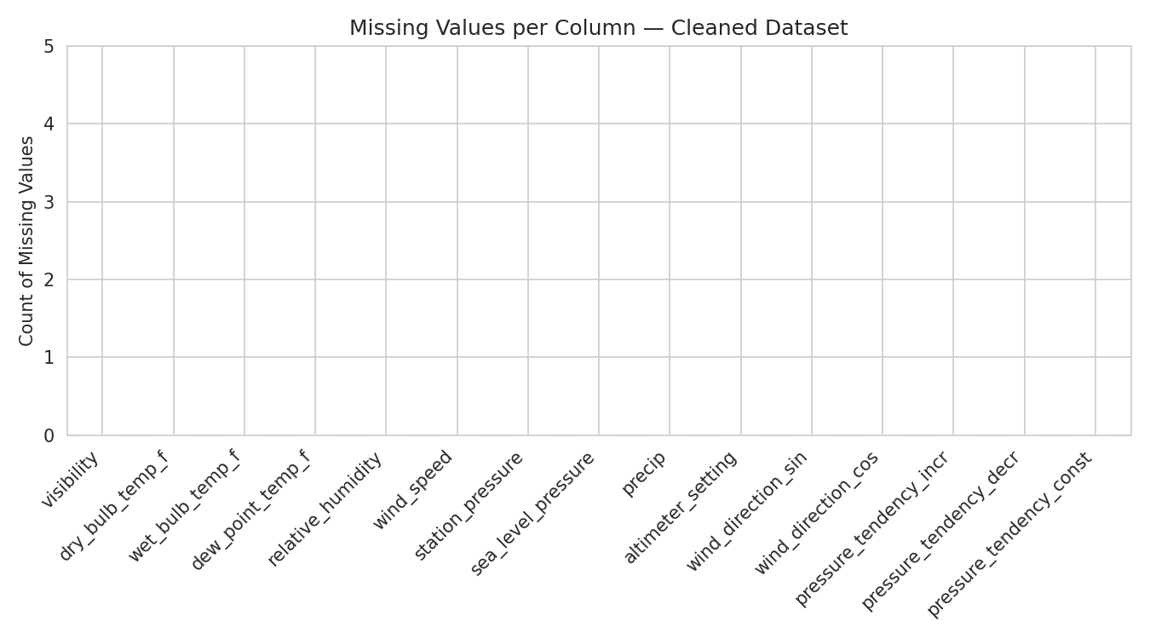
Figure 1. Missing values per column in the cleaned dataset.
What it shows: Every column reports zero missing values, confirming that the imputation step in Section 3.7 fully resolved the gaps present in the raw data. Run on the raw file prior to cleaning, this same chart shows real, non-zero gaps in several fields — it is included here as the after side of that verification.

4.2 Correlation Between Variables
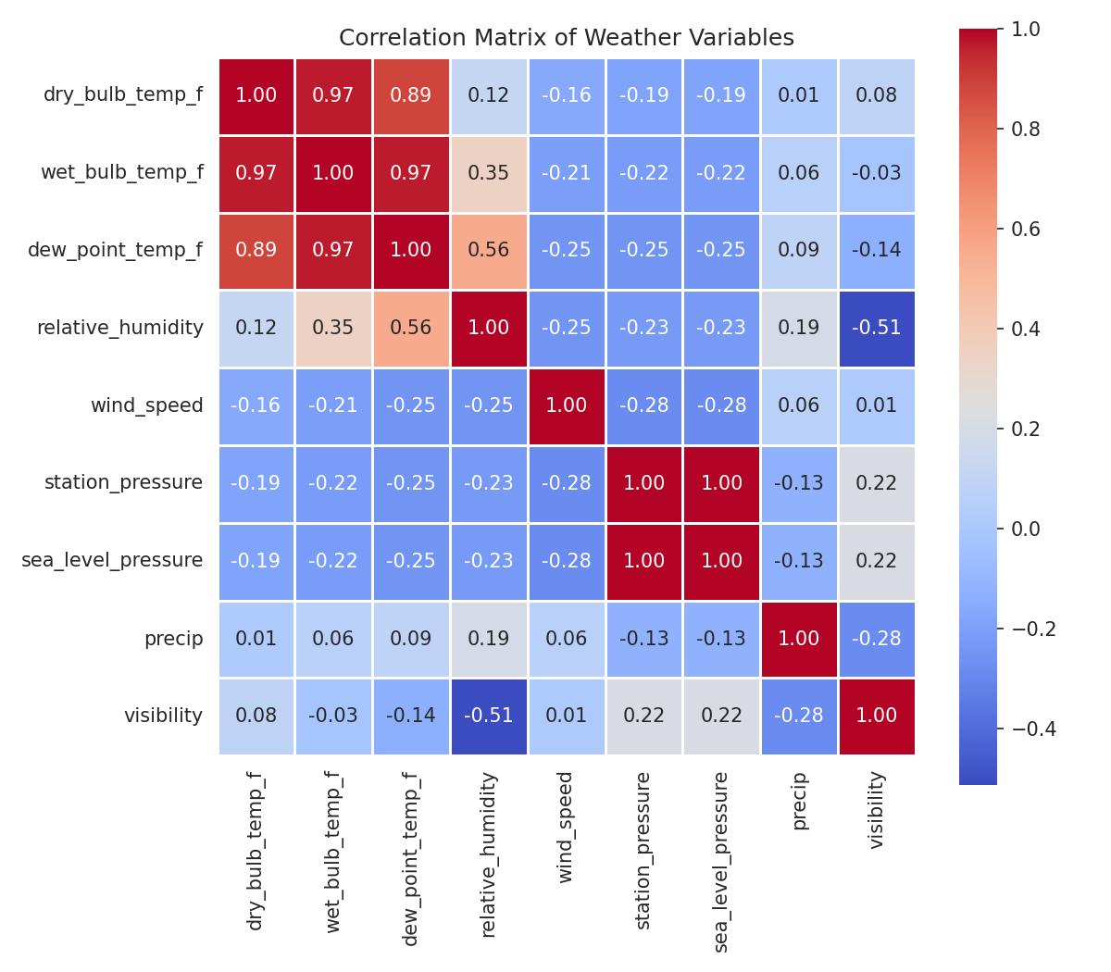
Figure 2. Correlation matrix of nine key weather variables.
What it shows: The three temperature measures (dry bulb, wet bulb, dew point) are very strongly correlated (r = 0.89–0.97), as are the two pressure measures (r = 1.00). Relative humidity and visibility show the strongest negative relationship in the dataset (r = -0.51), consistent with the physical fact that saturated, humid air is what produces fog and reduced visibility.

4.3 Temperature Distribution
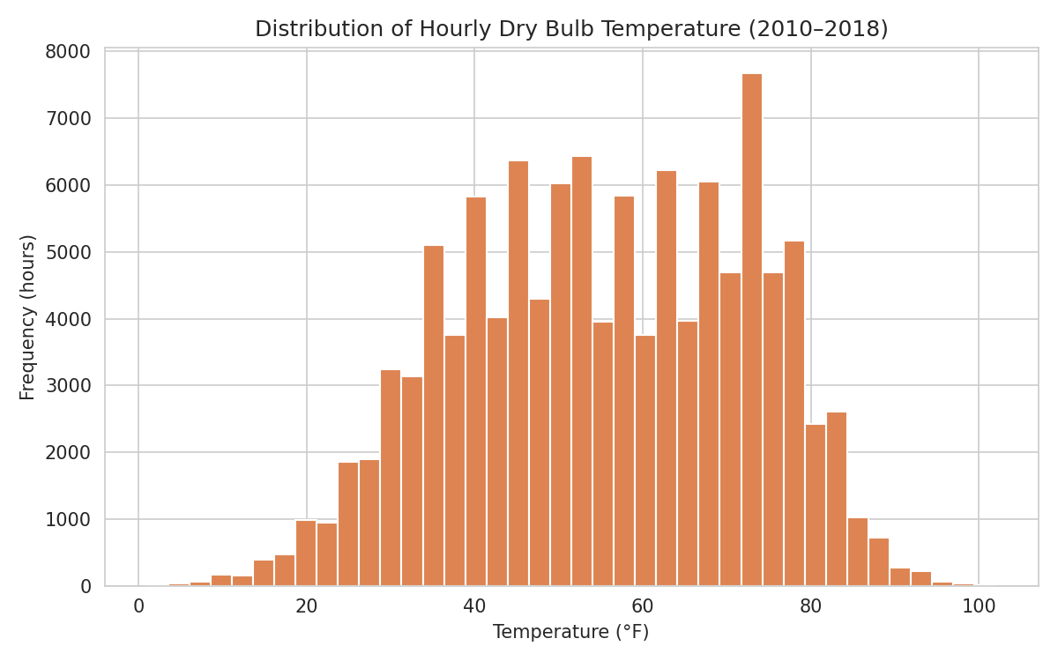
Figure 3. Distribution of hourly dry bulb temperature, 2010–2018.
What it shows: Hourly temperature readings are broadly spread and roughly bell-shaped, concentrated between 30–80°F with a pronounced spike near 70°F. The distribution is not symmetric, reflecting New York's longer, more gradual cold season versus a more compressed warm-season peak.

4.4 Seasonal Trend and Outlier Check
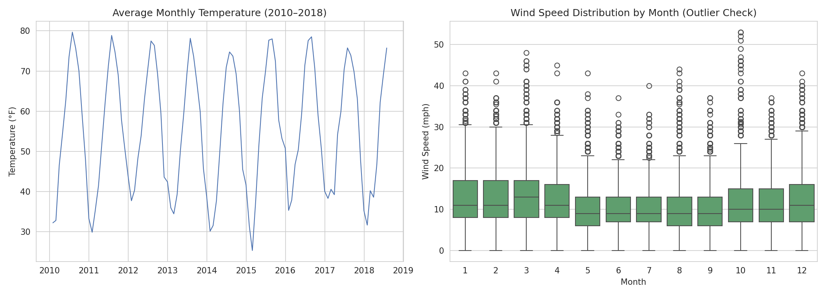
Figure 4. Monthly average temperature (left) and monthly wind-speed distribution with outliers (right).
What it shows: The left panel confirms a clean, repeating annual temperature cycle across all nine years of data. The right panel shows wind speed by month using a box plot, which reveals extreme gust outliers reaching roughly 50 mph — a pattern a simple monthly average would have hidden entirely.

5. Summary of Insights
- The cleaning pipeline fully resolved all missing values (0 of 114,544 rows affected in the final dataset), verified against the documented NOAA range specifications rather than default null handling alone.
- Temperature-related fields (dry bulb, wet bulb, dew point) are highly redundant with one another (r > 0.89), suggesting a downstream model could safely drop one or two without losing meaningful information.
- Station pressure and sea-level pressure are functionally identical in this dataset (r = 1.00) and could be treated as a single feature.
- Humidity and visibility are the most strongly (negatively) related pair among non-redundant variables, pointing to humidity/dew-point proximity as a useful predictor of low-visibility conditions in future analysis.
- Temperature follows a clear, repeatable seasonal cycle, while wind speed's most operationally significant feature is not its average but its outliers, which cluster in colder months.

Potential Areas for Further Analysis
- Model low-visibility risk directly as a function of the humidity/dew-point gap identified in Section 4.2.
- Examine whether wind-speed outliers correlate with specific pressure-tendency states (rising/falling/steady).
- Extend the seasonal trend analysis into a formal time-series forecast, as explored in the original reference notebook this workflow was adapted from.

6. Conclusion
Starting from a raw, imperfect hourly weather feed, this workflow produced a fully validated, gap-free dataset of 114,544 hourly observations and used exploratory analysis to surface concrete, verifiable patterns — seasonal temperature cycles, variable redundancy, and the physical relationship between humidity and visibility. These findings both confirm the cleaning process was successful and identify specific, well-motivated directions for further analysis.

